How Debezium Uses PostgreSQL WAL for Change Data Capture
In the previous article, we explored what Write-Ahead Logging (WAL) is and why it sits at the center of PostgreSQL’s architecture.
Every change that happens inside PostgreSQL is first written to WAL before being applied to the actual table files.
Press enter or click to view image in full size
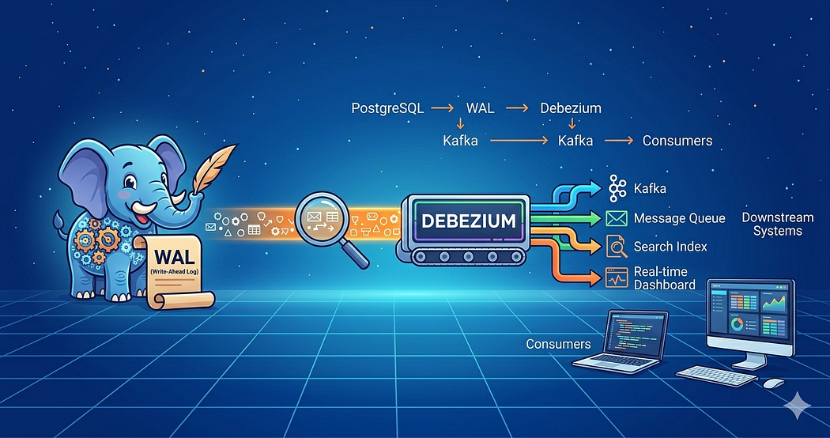
This design ensures that the database can recover to a consistent state after a failure.
Because WAL records every change happening inside the database, it can also be used to stream those changes to other systems in real time.
This is exactly the idea behind Change Data Capture (CDC).
Instead of repeatedly querying database tables to detect updates, CDC systems read the database’s change log and convert those changes into events that other systems can consume.
One of the most widely used CDC platforms for PostgreSQL is Debezium.
Debezium reads PostgreSQL’s WAL and turns database operations into a continuous stream of events that can be processed by downstream systems.
Why Applications Need Change Data Capture
Modern applications rarely operate in isolation.
A single database update might need to trigger actions across several systems.
Consider a simple update:
UPDATE users
SET name = 'Alice Cooper'
WHERE id = 1;
This change might need to propagate to multiple places.
For example, an application might need to:
- update a search index
- refresh analytics dashboards
- synchronize data into a data warehouse
- trigger downstream workflows
A common approach is to periodically query the database to detect changes.
But this approach quickly runs into problems.
Polling databases repeatedly increases load, introduces delays, and becomes difficult to scale as systems grow.
Change Data Capture solves this problem by streaming database changes as they happen.
Why WAL Makes CDC Possible
PostgreSQL records every modification inside WAL before writing the change to the actual data files.
This means WAL effectively contains a chronological record of everything that happens inside the database.
Because of this, CDC systems do not need to read tables directly.
Instead, they simply read the WAL stream.
A simplified view of the process looks like this:
Application query
↓
PostgreSQL writes change to WAL
↓
CDC system reads WAL
↓
Change event generated
This approach is both efficient and reliable because the CDC system processes changes in the exact order they occurred.
Debezium follows this approach.
Rather than querying tables, it reads PostgreSQL’s WAL and converts the changes into structured events.
Enabling Logical Decoding in PostgreSQL
For external systems to interpret WAL records, PostgreSQL must include enough information about row-level changes.
This is controlled by the wal_level configuration.
wal_level = logical
PostgreSQL supports several WAL levels.
- minimal - used only for crash recovery
- replica - supports physical replication
- logical - includes additional metadata required for logical decoding
When the WAL level is set to logical, PostgreSQL records enough information for external systems to reconstruct database changes.
This capability is known as logical decoding.
Replication Slots and Tracking WAL Consumption
When Debezium connects to PostgreSQL, it creates something called a replication slot.
A replication slot is a mechanism that allows PostgreSQL to track how far a consumer has read the WAL stream.
Get Mohamed Hussain S’s stories in your inbox
Join Medium for free to get updates from this writer.
Subscribe
Remember me for faster sign in
This ensures that WAL segments are not removed before the CDC system has processed them.
The process works like this:
Debezium reads WAL
↓
PostgreSQL records last consumed position
↓
WAL segments retained until consumed
The position in WAL is identified using a value called the Log Sequence Number (LSN).
Because the replication slot tracks the last processed LSN, Debezium can resume streaming changes from the correct position even if the connector restarts.
Logical Decoding Plugins
WAL records are stored in a binary format that is not directly readable.
To convert these records into logical database changes, PostgreSQL uses logical decoding plugins.
These plugins interpret WAL records and transform them into a structured format.
Some commonly used plugins include:
- pgoutput
- wal2json
- decoderbufs
The default plugin used by PostgreSQL is pgoutput, which is also commonly used with Debezium.
How Debezium Streams Database Changes
Once everything is configured, the change data capture pipeline works as follows.
An application writes data to PostgreSQL.
PostgreSQL records the change in WAL.
The logical decoding plugin interprets the WAL records.
Debezium reads those decoded changes through PostgreSQL’s replication protocol.
The connector then publishes the changes as events to a messaging system such as Kafka.
A simplified architecture might look like this:
PostgreSQL
↓
Debezium
↓
Kafka
↓
Consumers
Downstream systems can then consume these events and react accordingly.
This architecture enables event-driven systems where database changes propagate automatically to other services.
Example Change Event
When Debezium captures a change from WAL, it converts that change into a structured event.
A simplified example might look like this:
{
"op": "c",
"table": "users",
"before": null,
"after": {
"id": 1,
"name": "Alice"
}
}
The op field represents the operation type:
- c - create
- u - update
- d - delete
Applications consuming these events can use them to trigger additional processing.
WAL as the Foundation for Multiple Systems
One interesting aspect of PostgreSQL’s design is that many different systems rely on the same WAL stream.
The same WAL records used for CDC are also used for:
- database replication
- backup systems
- point-in-time recovery
In many ways, WAL acts as the complete history of changes in a PostgreSQL database.
Final Thoughts
Change Data Capture allows systems to react to database changes without constantly querying tables.
PostgreSQL makes this possible because every modification is recorded in WAL.
Tools like Debezium simply read that stream of changes and convert it into events that other systems can consume.
This makes it possible to build scalable, event-driven architectures directly on top of relational databases.

